| **Test Name** | | Search for a User | | | |
| --- | --- | --- | --- | --- | --- |
| **Use Case Tested:** | | Use Case – Search for a User | | | |
| **Test Description:** | | User finds a record entered for a User  User navigates to Search tab and selects Users, or selects Search Users button from welcome page  User is presented with a list of users  User can search on all visible fields | | | |
| **Pre-conditions** | | User must login as an administrator  User records must exist | | | |
| **Post-conditions** | | Records are presented to user | | | |
| **Notes:** | |  | | | |
| **Result (Pass/Fail/Warning/Incomplete)** | |  | | | |
|  | **TEST STEP** | | **EXPECTED TEST RESULTS** | P | F |
|  | User selects “Search > Search Users” from the menu bar or selects Search Users button on Admin Home page | | A list of user records is returned – using tab  A list of user records is returned – using button | X  X |  |
|  | User enters a search for an Authentication level | | Records meeting criteria are returned | X |  |
|  | User enters a search for a Username | | Records meeting criteria are returned | X |  |

|  |  |  |  |  |  |
| --- | --- | --- | --- | --- | --- |
| **Test Data Table** | | | | | |
|  | **1** | **2** | **3** | **4** | **5** |
| Test – 1 | Authority= 1 | Username = frank |  |  |  |
| Test – |  |  |  |  |  |
| Test – |  |  |  |  |  |

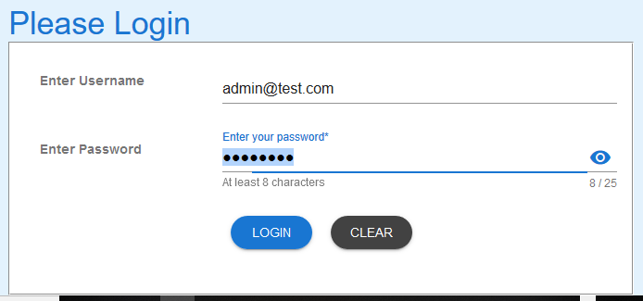

Figure 1: Login as administrator

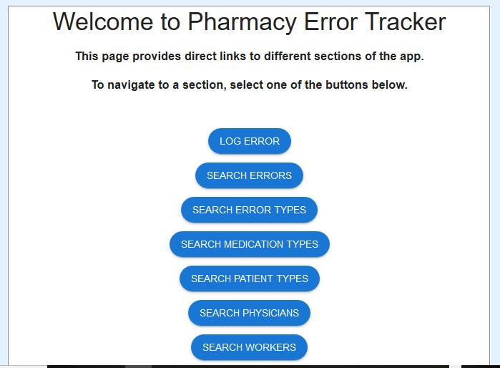

Figure 2: Welcome page for Administrator

\

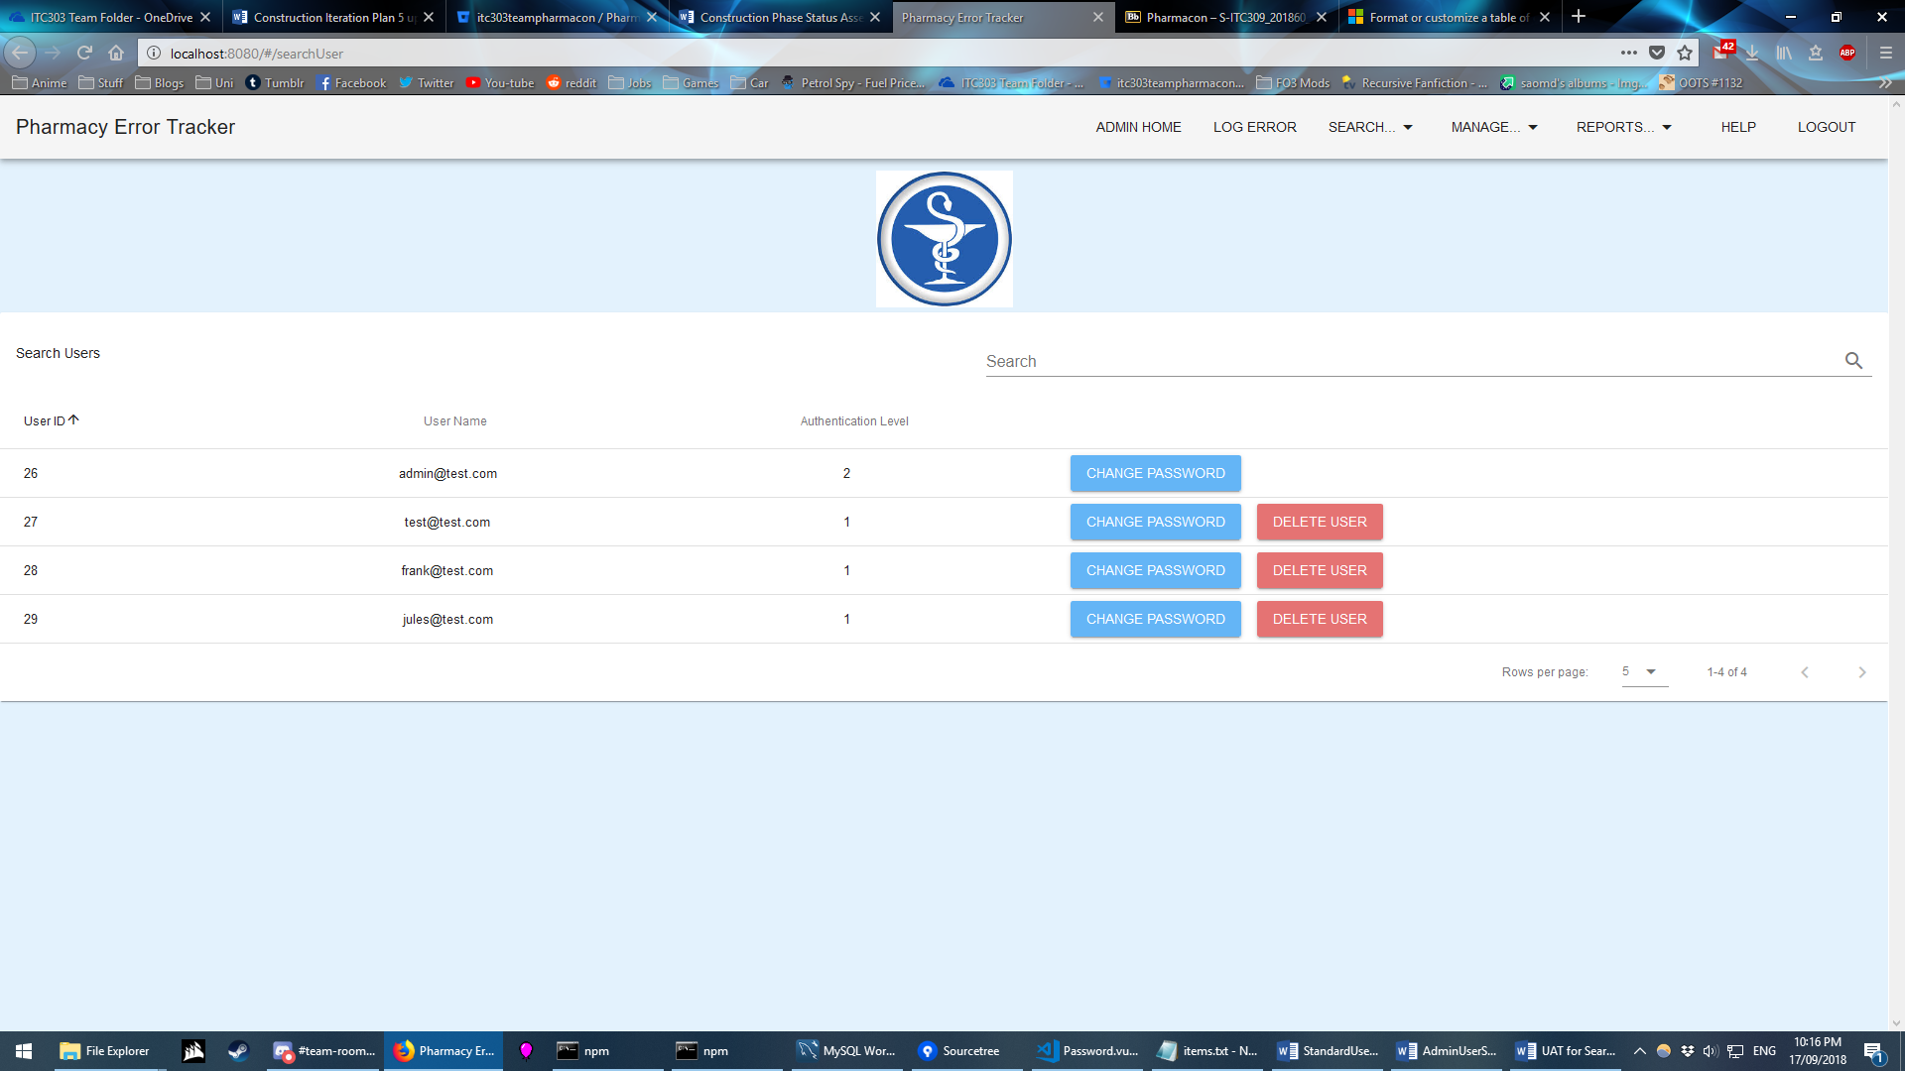

Figure 3: Using Search Tab – list of User records presented

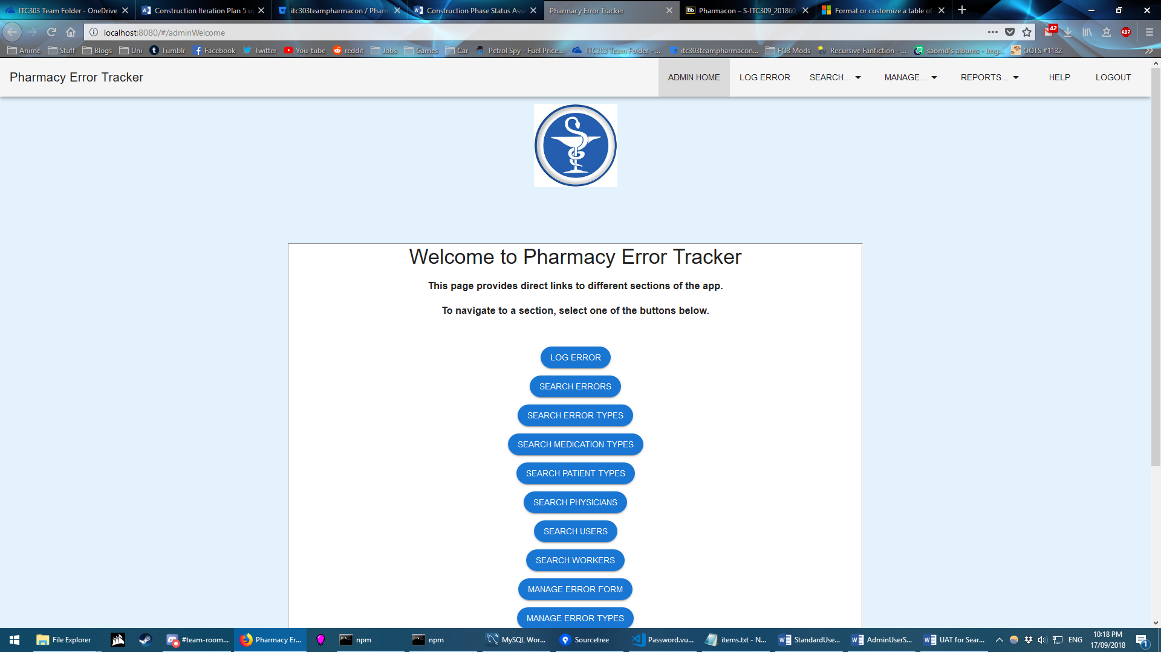

Figure 4: Button – Search Users – selected



Figure 5: List of Users records presented

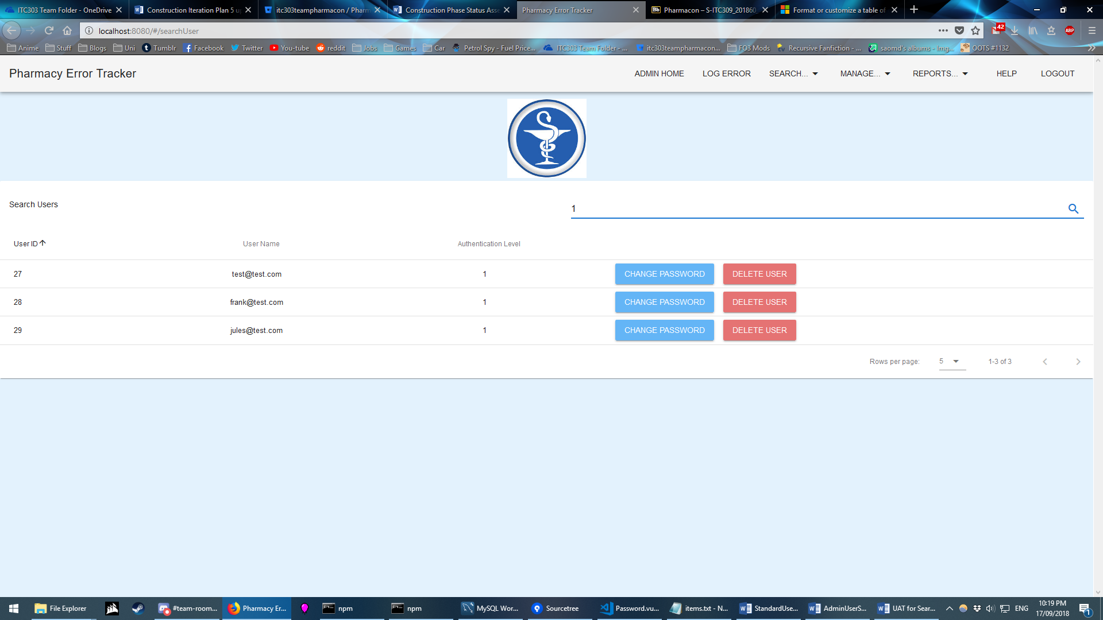

Figure 6: All records containing “1” returned

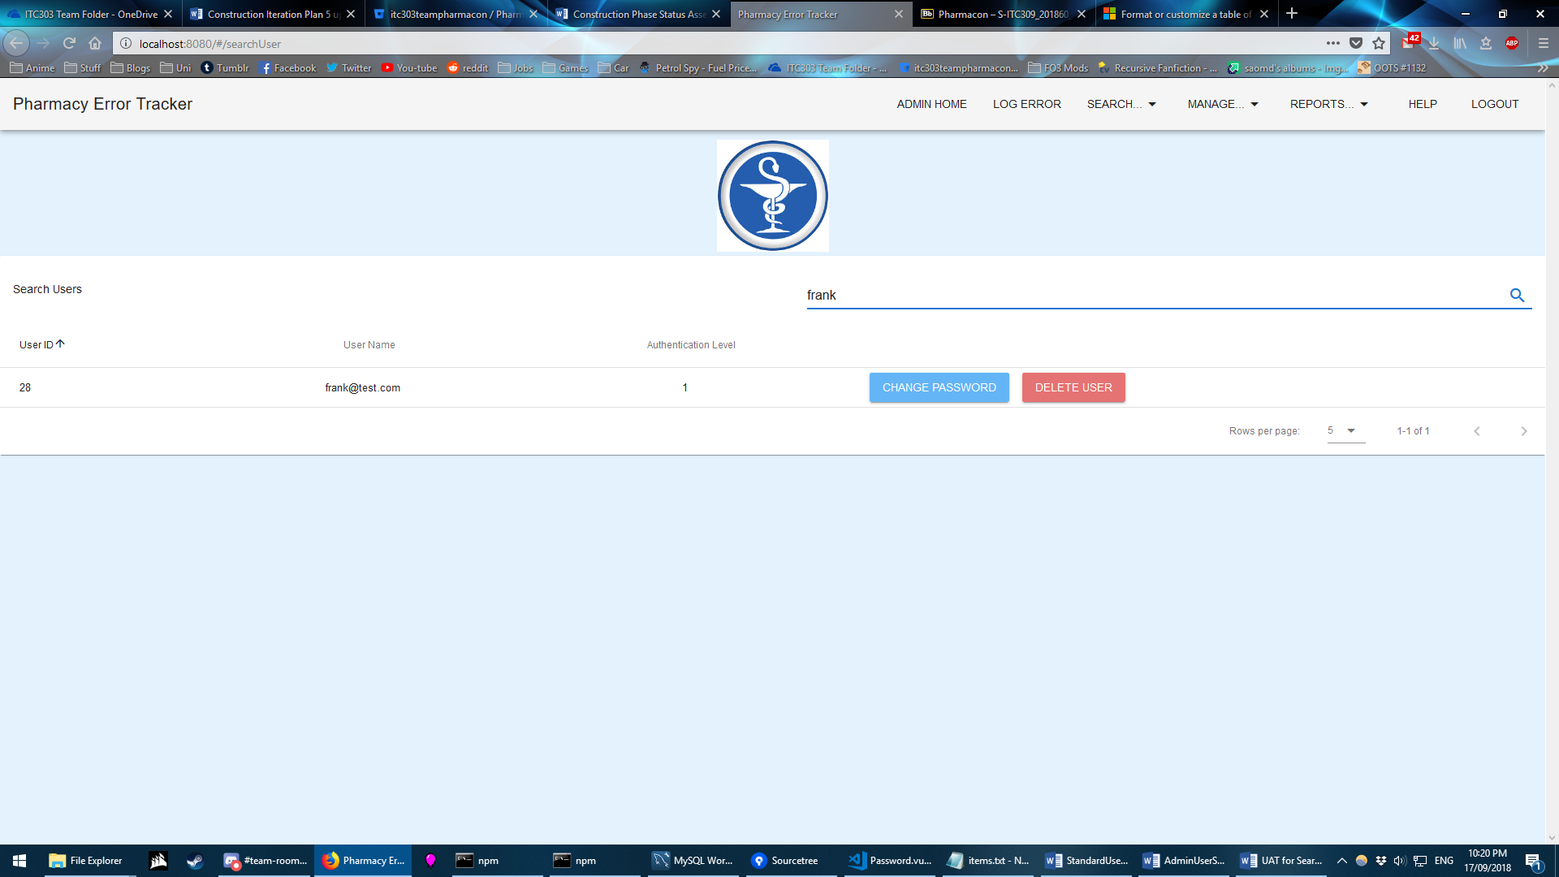

Figure 7: All records containing “frank” returned

EXPECTED ERROR MESSAGES:

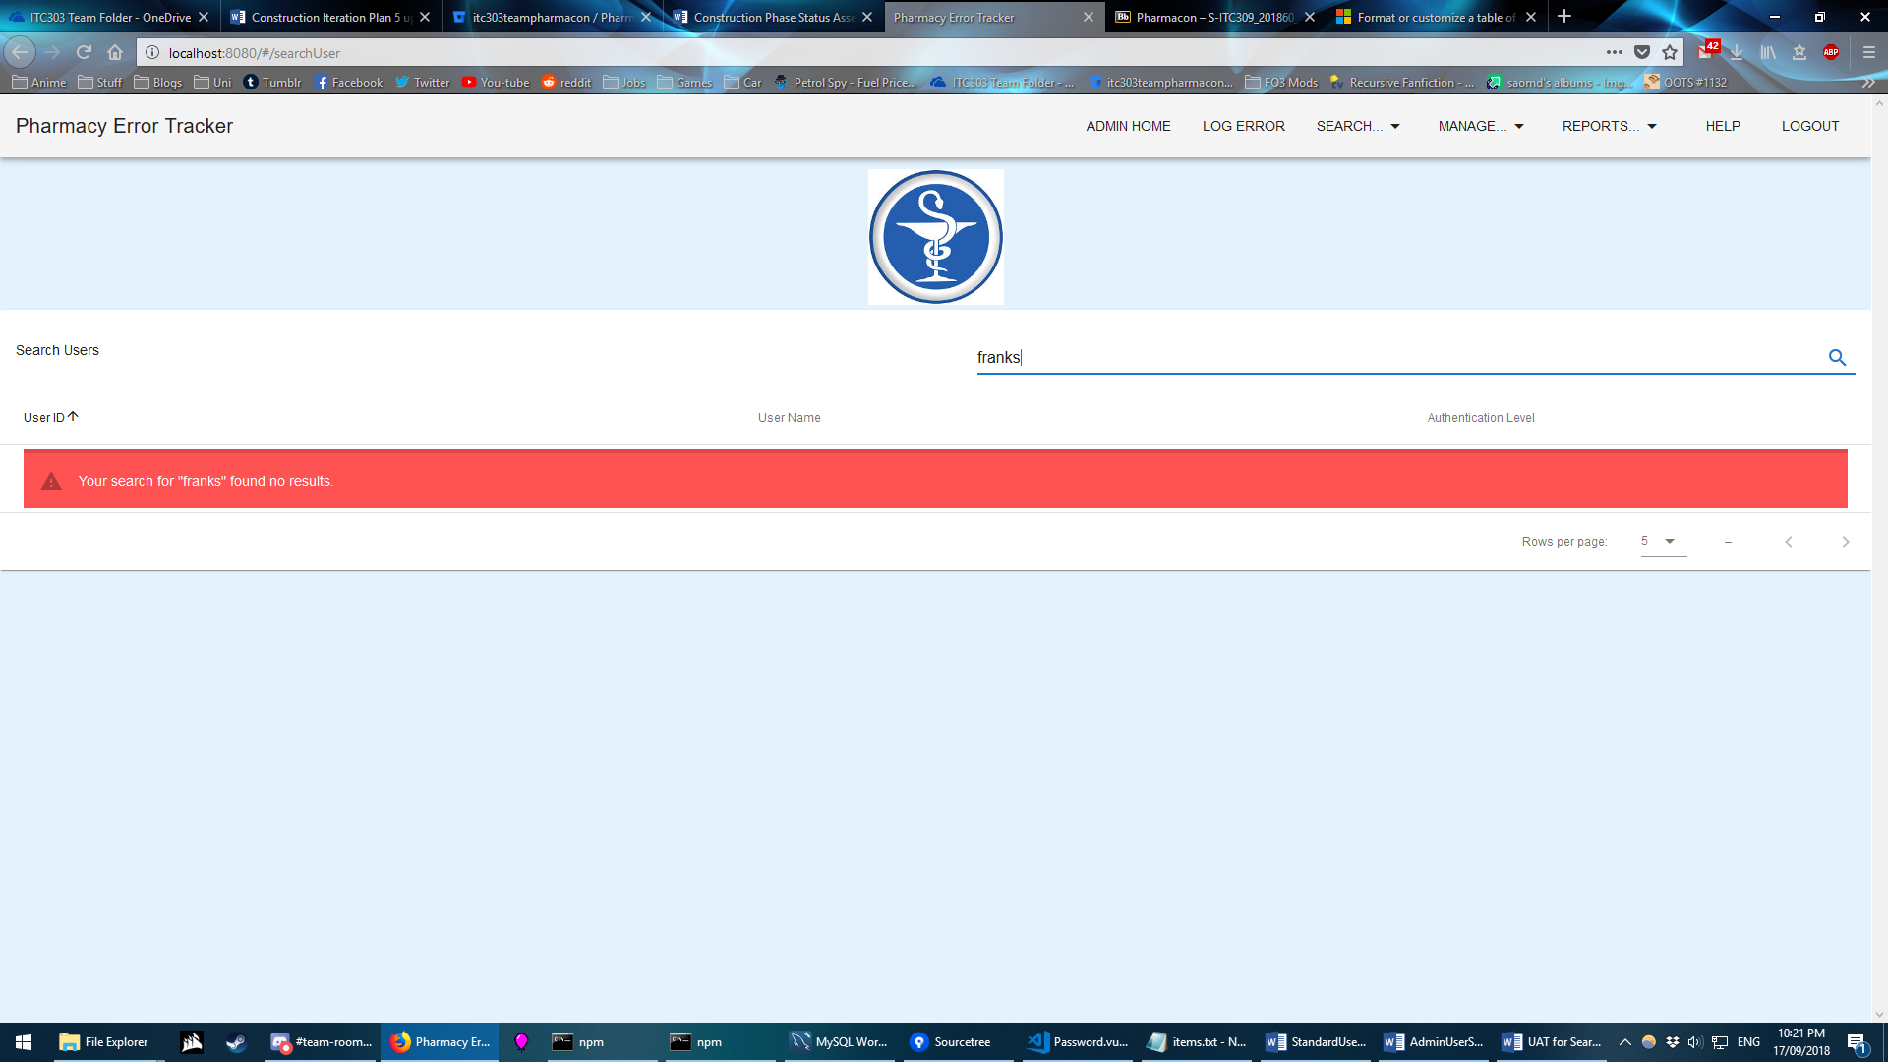

Figure 8: Error message expected if no record meets criteria - user - Expected

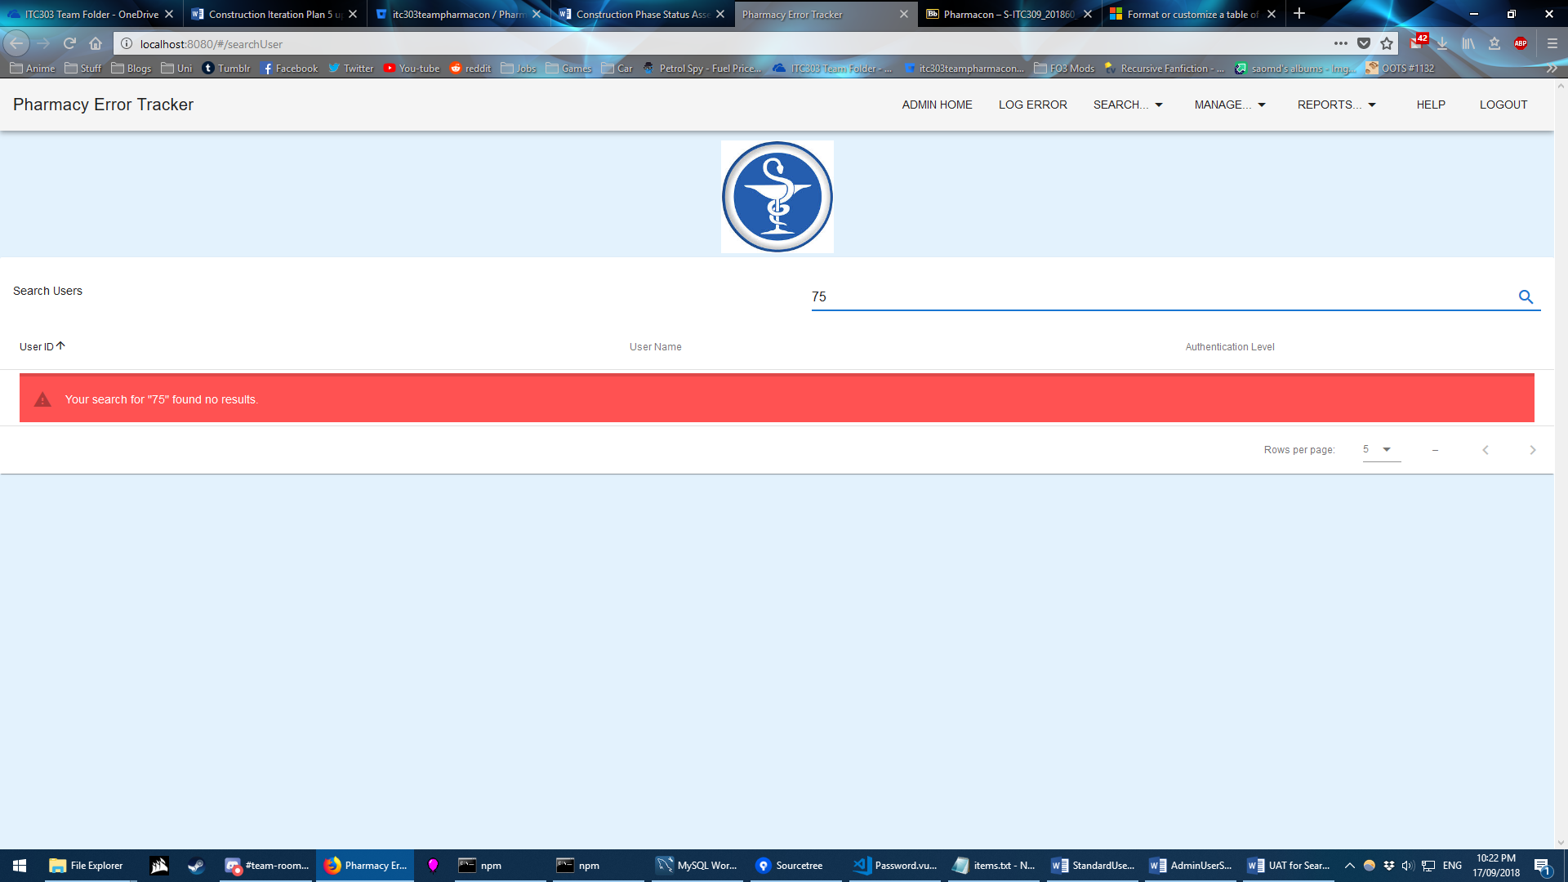

Figure 9: Error message expected if no record meets criteria – Authentication level - Expected